Pre Assessment

**Exercise 1**

Define the following key Object Orientated Programming (OOP) principles with examples:

1. **Encapsulation:**
2. It a process of wrapping code and data together to form into a single unit. It is more than just defining accessor and mutator methods for a class, it is a broader concept of object oriented programming that consist in minimizing the interdependent of classes and it is typically implemented through information hiding.
3. The public setter and getter methods are the access points of the instances variable of the Standard_Ticket class. Any other classes that need to access the variable can go through get and set process as shown below.
   1. **Code sample**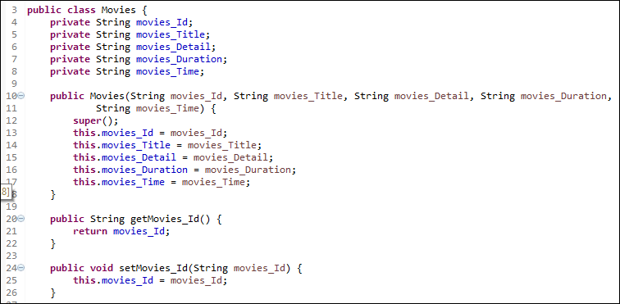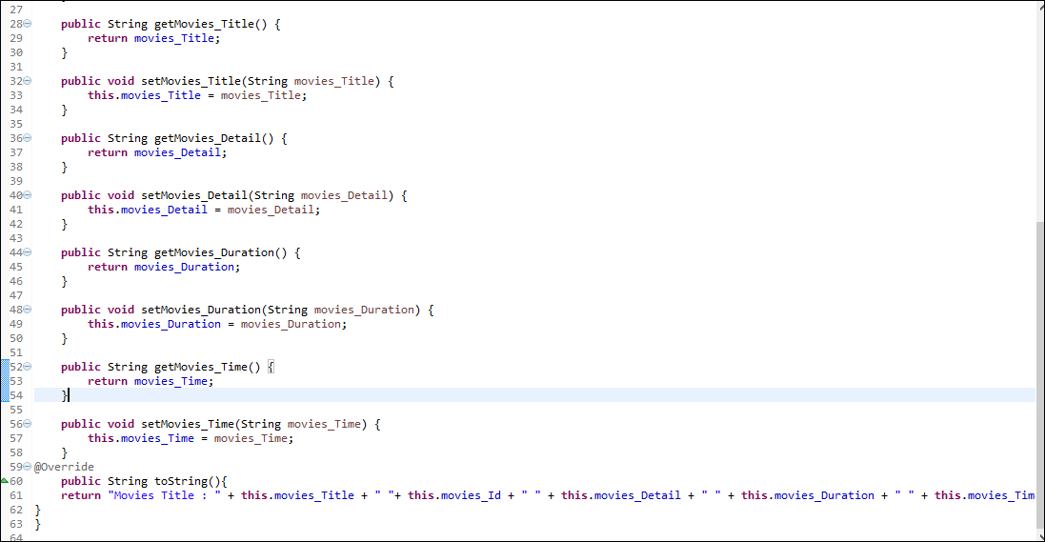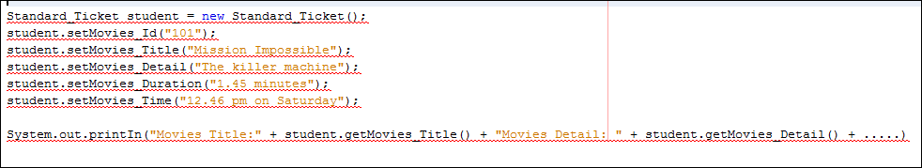

1. **Inheritance:**
2. Inheritance is a process whereby one class acquires the properties (methods and fields) of another.
3. It can also be defined as the mechanism in which one object acquires all the properties and behaviour of parent object. The inheritance represent the “**IS-A relationship”** and also known as parent-child relationship. It is used as a method overriding that allows the runtime polymorphism to achieve its function. It also make the code to be reusable.
4. e.g.
5. class **subclass-name** extends **superclass-name** {
6. // methods and fields ……………goes here
7. }
8. The “E**xtends”** keywords indicates that new class are been derives from the existing class.
9. 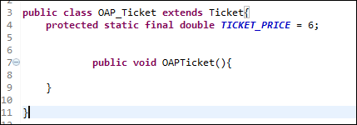

The inheritance is used mostly in the java language because it is everywhere. It is impossible to write even the tiniest java program without using inheritance.

1. Code Sample:

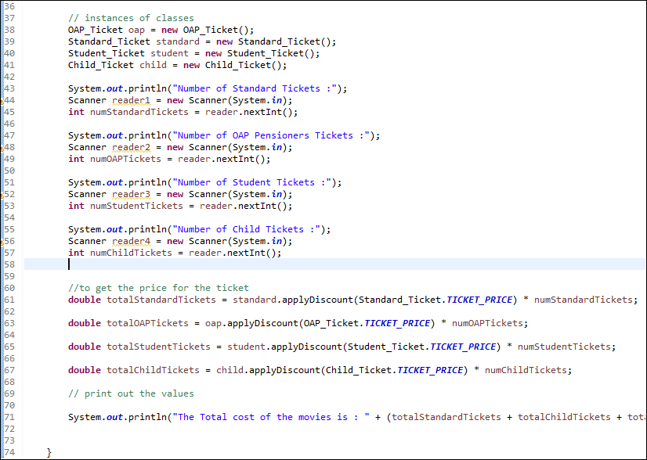

**Another Example:**

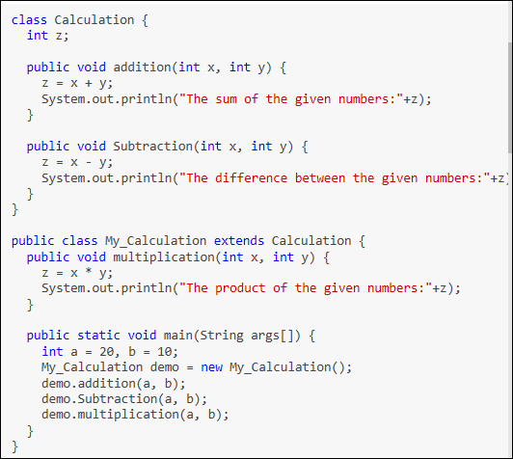

[**https://www.bing.com/search?q=inheritance+in+java&go=Search&qs=bs&form=QBRE**](https://www.bing.com/search?q=inheritance+in+java&go=Search&qs=bs&form=QBRE)

**Another example:**

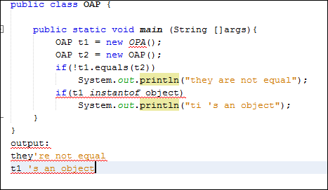

(Source: oracle textbook)

1. **Polymorphism:**
2. Polymorphism is the ability of two different objects to respond to the same request message in their own unique way. The dog could be train to respond to the command bark and Bird may respond to the command Chirp. While both could be trained to respond to the command speak.

### Code sample

### 

### 

### Polymorphism is the ability of an object to take on many forms. The most common use of polymorphism in OOP occurs when a parent reference is used to refer to child class object.

### 

### 

### 

1. **Abstraction:**
2. Abstract class can never be instantiated but they can be subclassed. It means that you cannot create new instances of an abstract class.
3. Abstract class can be compile and execute an abstract class, as long as you don’t try to make an inheritance of it.

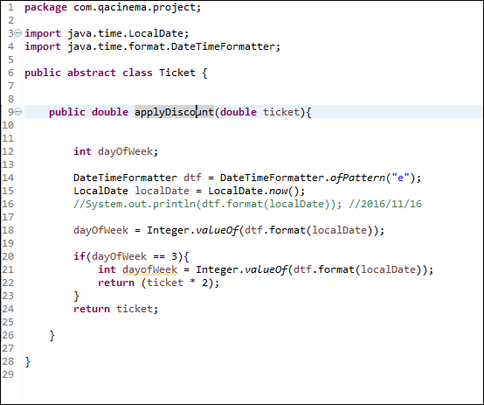

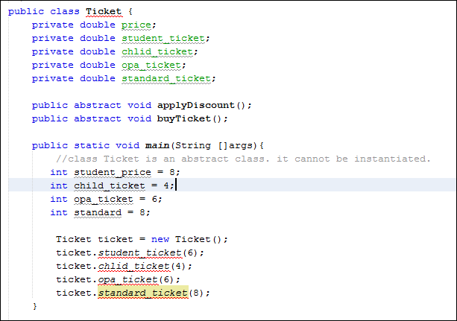

The information above shows that if the program is compile, there might be an error. In addition, to fix it a code sample that includes a method ending in a semicolon, but without an abstract modifier on the class or method. The method and claas abstract could be marked or change the semicolon to code (i.e change the semicolon at the end of the method declaration into a curly brace pair.)

**Abstract**